APPROVED ARCHITECTURE DECISION
Building BIOS and Digital Twin
Authoritative Source, Synchronization, and Lifecycle Relationship
Document ID: S05-AD-028
Version: 0.1
Status: APPROVED
Approval date: 20 July 2026
Classification: Constitutional Architecture Decision
Supersedes: None
Constitutional relationship: Extends S05-CON-001 and S05-CON-002 without modifying their approved text.

Decision Summary
The Building BIOS is the authoritative digital source of a System05 building. The Digital Twin is the building's continuously synchronized operational representation. The Digital Twin is initialized, configured, and updated by the Building BIOS; observed physical data enters the Digital Twin; and only verified physical and lifecycle events may be returned to the Building BIOS.
This decision is approved as the governing System05 definition for the relationship between Building BIOS, Digital Twin, and the physical building. Future BDL, Engineering Compiler, Digital Engineering, lifecycle, interface, and compatibility specifications shall conform to it.

1. Purpose and Scope
System05 requires a persistent digital environment that begins before the physical building exists, grows with the engineering work, governs authorized configuration, and remains active throughout the building lifecycle. This decision formally assigns that role to the Building BIOS and defines the Digital Twin as the synchronized operational representation derived from and governed by that authoritative source.
For a new System05 building, the Building BIOS instance shall be created at project inception. For a legacy or hybrid building entering the System05 ecosystem, a Building BIOS instance shall be initialized from verified survey, identification, inspection, and as-built evidence before it is accepted as authoritative.

2. Approved Definitions

2.1 Building BIOS
The System05 Building BIOS is a versioned, persistent, and uniquely identified digital environment created at the inception or onboarding of a building. It progressively receives, organizes, validates, and governs the building's spatial, architectural, structural, component, interface, assembly, operational, and lifecycle information.
The Building BIOS is the authoritative source for the building's approved definition and configuration. It is not limited to embedded firmware and it is not merely a document repository. It is the governed information substrate from which compatibility decisions, Engineering Compiler outputs, manufacturing packages, assembly instructions, commissioning records, and Digital Twin initialization are produced.

2.2 Digital Twin
The System05 Digital Twin is the continuously synchronized operational representation of a physical building and its significant assets. It receives the authorized building definition, component identities, approved configuration, and validated lifecycle changes from the Building BIOS, while also receiving observed conditions from sensors, inspections, tests, controllers, and other authorized physical data sources.
Before a physical asset exists, the evolving representation shall be treated as the Digital Building Definition, Virtual Building Model, or Pre-Construction Twin. It becomes an Operational Digital Twin when physical identities and verified as-built conditions are bound to the model during assembly and commissioning.

2.3 Authoritative Relationship
The Building BIOS governs what the building is authorized and expected to be. The Digital Twin represents what the building is currently understood to be. The physical building remains the real asset. These three elements form one controlled cyber-physical system, but they have distinct authority and update rules.
Digital Twin(t) = BIOS Definition + Verified Lifecycle Events + Current Physical Data

3. Information Authority and Synchronization
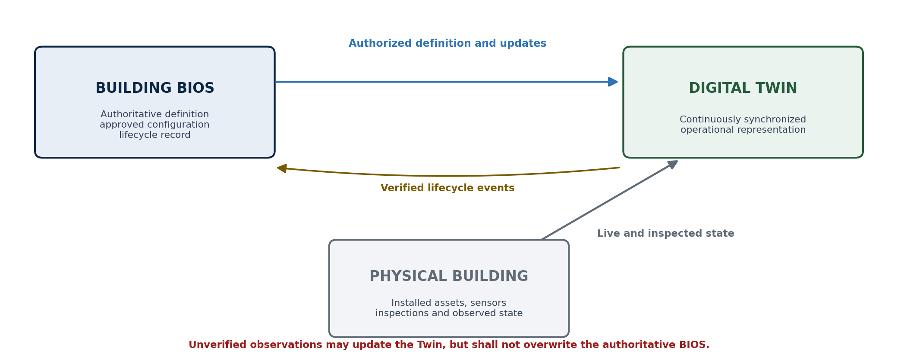
Figure 1. Approved information-authority flow between Building BIOS, Digital Twin, and the physical building.
Flow | Direction | Controlled content
Authorized definition flow | Building BIOS -> Digital Twin | Approved geometry, requirements, identities, versions, interfaces, configuration, and validated changes.
Observed-state flow | Physical Building -> Digital Twin | Sensor values, installation scans, inspections, tests, faults, condition, and operating state.
Verified return flow | Digital Twin -> Building BIOS | Only authenticated and verified lifecycle events, accepted as-built changes, approved replacements, and authorized upgrades.
Mismatch flow | Physical/Twin != BIOS | A discrepancy is recorded and classified; the authoritative BIOS is not silently overwritten.

4. Lifecycle Operating Model
The Building BIOS shall not be treated as permanently complete. It shall reach controlled baselines that are validated, released, and traceable. Each approved baseline may authorize a specific engineering, fabrication, assembly, commissioning, or operational action while later revisions continue the lifecycle record.
Lifecycle state | Building BIOS role | Digital Twin state
Genesis | Creates the building identity, project context, location, ownership/authority context, and initial requirements. | No operational twin; early digital definition begins.
Definition | Accumulates architectural geometry, spaces, loads, profiles, Node/Cartridge selections, interfaces, materials, tolerances, and intended assembly. | Virtual building representation evolves from BIOS data.
Validation and Release | Runs compatibility and rule checks; freezes an approved, traceable baseline for fabrication or assembly. | Reflects the released authorized configuration.
Fabrication and Assembly | Issues controlled packages and expected component identities; records verified production and installation events. | Compares planned state with scanned and installed state.
Commissioning | Accepts verified as-built identities, test results, inspection evidence, and approved deviations. | Becomes the Operational Digital Twin.
Operation and Change | Governs maintenance, replacement, upgrades, repairs, decommissioning, reuse, and future baselines. | Continuously reflects observed condition and synchronized approved change.

5. Compatibility Governance
Every Node, Cartridge, connection, interface, adapter, utility module, sensor, actuator, software component, and legacy component introduced into a Building BIOS instance shall be evaluated against the current authorized building definition and the applicable System05 registries and Engineering Profile.
Compatibility inputs. Identity and version; geometry and datums; mechanical, electrical, fluid, thermal, communication, and digital interfaces; capacities and demands; tolerances; regulatory profile; evidence and certification; assembly sequence; tool and robotic access; serviceability; replaceability; and lifecycle constraints.
Compatibility status | Approved meaning
Compatible | All mandatory checks are satisfied for the stated scope and configuration.
Conditionally Compatible | Use is permitted only under explicit conditions, limitations, adaptations, or additional verification.
Incompatible | One or more mandatory requirements are violated.
Unresolved | Available information or evidence is insufficient for a trustworthy decision.

6. Versioning and Identification
System05 shall distinguish the version of the BIOS platform from the identity and revision state of an individual building. A platform update shall not silently change an approved building baseline, and a building revision shall not be confused with an update to the BIOS engine.
Version layer | Meaning | Example
Building BIOS Engine | Version of the System05 BIOS software, schema, validation services, and supported protocols. | S05-BIOS v3.03
Building BIOS Instance | Permanent, globally unique identity of one building's authoritative digital environment. | S05-US-NJ-0000127
Building Definition Revision | Traceable revision or approved baseline of that building's definition and configuration. | D-018
Registry Dependencies | Exact Node, Cartridge, Interface, material, evidence, and Engineering Profile registry versions used by the baseline. | Node Registry v2.04

7. Approved Constitutional Rules
AD-028-R01 Every new System05 building shall begin as a uniquely identified Building BIOS instance before physical construction.
AD-028-R02 A legacy or hybrid building shall receive a Building BIOS instance through a verified onboarding and as-built capture process.
AD-028-R03 The Building BIOS shall be the authoritative source for approved building definition, configuration, identity, version, and lifecycle records.
AD-028-R04 The Digital Twin shall be initialized, configured, and updated from the Building BIOS.
AD-028-R05 The Digital Twin shall receive current physical state only through authorized sensors, inspections, tests, scans, controllers, or other trusted data channels.
AD-028-R06 Unverified observations shall not overwrite the authoritative Building BIOS.
AD-028-R07 Verified as-built conditions, accepted deviations, maintenance actions, replacements, repairs, and upgrades shall be returned to the Building BIOS as traceable lifecycle events.
AD-028-R08 A difference between the Building BIOS, Digital Twin, and physical building shall be recorded as a controlled mismatch and shall not be silently reconciled.
AD-028-R09 Each component introduced into a Building BIOS instance shall be evaluated for compatibility against the current authorized baseline and applicable registries.
AD-028-R10 Every released baseline shall preserve the exact versions of the BIOS engine, BDL schema, Engineering Profile, and dependent registries used for validation.
AD-028-R11 A Building BIOS shall remain active throughout fabrication, assembly, commissioning, operation, maintenance, upgrade, disassembly, reuse, and end-of-life activities.
AD-028-R12 The Building BIOS and Digital Twin shall remain vendor-independent and machine-readable wherever practical.

8. Canonical System05 Language

8.1 Short Form
The Building BIOS is the authoritative digital source of the building, while the Digital Twin is its continuously synchronized operational representation.

8.2 Full Form
The System05 Building BIOS is a versioned, persistent digital environment created at the inception or verified onboarding of every building. It progressively receives, organizes, validates, and governs the building's spatial, architectural, structural, interface, component, assembly, operational, and lifecycle information. The Digital Twin is initialized, configured, and continuously updated from the Building BIOS, while authorized physical observations update the Twin and verified lifecycle events are returned to the BIOS. The Building BIOS therefore remains the authoritative digital source, and the Digital Twin remains the synchronized operational representation of the physical building.

9. Constitutional Alignment and Future Work
This decision implements the S05-CON-002 principles of Single Source of Truth, Lifecycle Continuity, Machine Readability, Traceability, vendor independence, and continuously synchronized Digital Twin representation. It also supports the S05-CON-001 requirements for interpretable engineering information, AI and robotics readiness, component identity, assembly verification, and long-term physical-digital alignment.
This decision establishes authority and relationship but does not yet prescribe the final database technology, storage topology, serialization format, cybersecurity implementation, synchronization protocol, API design, hardware controller, or commercial software interface. Those matters shall be defined in subsequent Building BIOS, BDL, Engineering Compiler, Digital Twin, Digital Identity, Interface Protocol, and Security specifications without contradicting this approved decision.

10. Approval Record
Decision: Approved and accepted as an authoritative System05 architecture decision.
Effective date: 20 July 2026.
Application: Binding upon future System05 constitutional, architecture, language, compiler, registry, compatibility, digital engineering, and lifecycle documents unless formally superseded by a later approved decision.
Source baseline: S05-CON-001 - Vision, Mission & Philosophy, Version 0.1; S05-CON-002 - Engineering Principles & System Architecture, Version 0.1.

